Activity
Let’s reference

Choose up to 2 books and 2 magazines/journals that you think will be useful to your course.

Type of resources | Format (what should it look like?) | Your example
Book (1 author)   | Surname, initial. (Year). Title (in italics or underlined). Ed number (if it has one or is not a 1st ed). Place of publication: Publisher.
Book (2 author)   | Surname, initial. And Surname, initial. (Year). Title. Ed number. Place of publication: Publisher
Book (3 or more authors)   | Surname, initial., Surname, initial. And Surname, initial. (Year). Title. Ed number. Place of publication: Publisher
Book (editors only)   | Surname, initial. And surname, initial. (ed. Or eds.). (Year). Title. Place of publication: Publisher.
Book (chapter within a book)  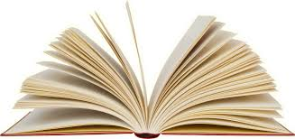 | Chapter author(s) surname, initial. (Year). Title of chapter. In: ed name and surname (ed). Title of book. Ed number. Place of publication: Publisher, page range.
Journal / magazine   | of journal article. Title of journal (in italiacs or underlined), volume number  (part/issue/month/season number goes here) page range

